Sunseeker Project Report
George Barry, James Dilts, Kyle Noll

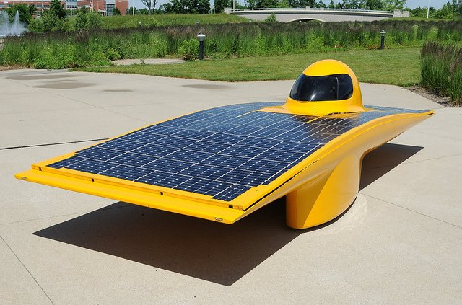

Background

Introduction
This Sunseeker project’s purpose is to update the current program dealing with CAN bus system currently being used on the Sunseeker solar car, making it easier to find specified data in the output.

Client Introduction
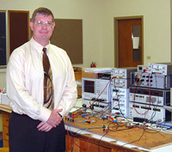

Our client is Dr. Bazuin of WMU's electrical engineering department, who is the lead advisor to the Sunseeker solar car team at WMU. Dr. Bazuin is also currently the lead designer for the on-board telemetry components and primary user of the CANUSB software. Over the past few years he has grown exceedingly annoyed by the need to manually filter and process data from the CANUSB software and has sought the assistance of our team.
Fig 1-1
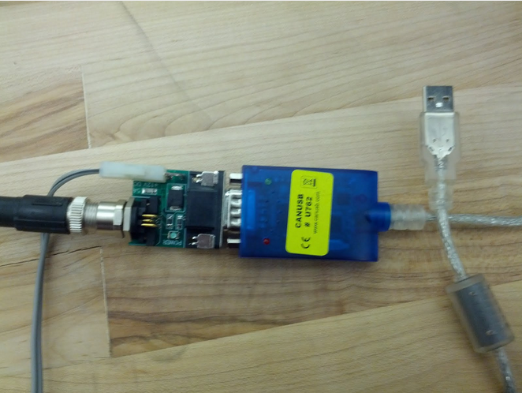

CANUSB Background
The problematic LAWICEL utility connects with the CAN system through the use of calls to the FTDI USB module in the CANUSB adapter in Fig 1-1.
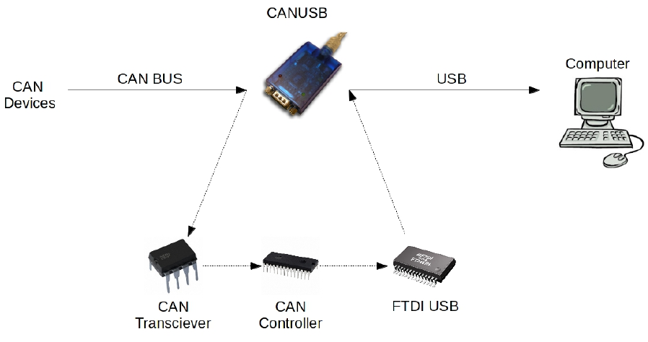
The CANUSB device actually consists of three primary modules as shown in Fig 1-2. When a message is sent by a device on the CAN bus and received by the CANUSB's CAN transceiver, it takes the LVDS that is used by the bus and converts it to digital I/O that the CAN controller module can understand. The CAN controller is the device that actually builds the complete CAN frame and once complete transmits it to the FTDI USB module. Once the FTDI module receives the CAN, it stores the frame in a 32 frame deep FIFO buffer. This buffer, upon request, is then sent to the connected computer using full-speed USB 2.0.
Fig 1-2

The LAWICEL utility allows the user to interact with the CAN bus through the use of the GUI shown in Fig 1-3. The LAWICEL software allows the user to build and send messages across the CAN Bus. They can be sent as a single message, burst or a big burst. The software also lets the user read in all of the output from the CAN bus, and displays the messages in a text box (highlighted in Fig 1-3) with each message on a separate line. The user has the option of telling the software to display messages with a certain id and/or flag first on each set of incoming messages.
Fig 1-3
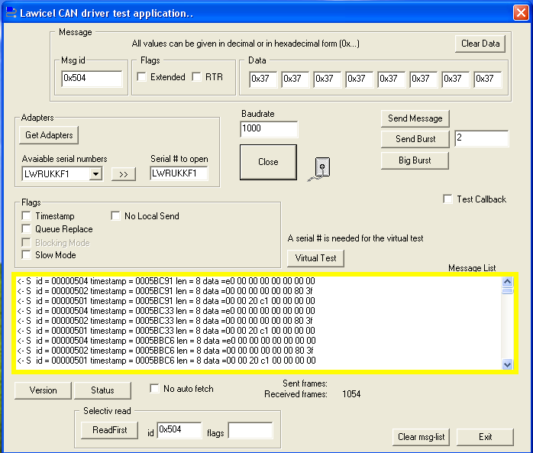

Shortcomings of LAWICEL utility

The current CANUSB software is lacking in several areas of usability. It does not allow for message filtering or perform any translation/computation on the messages being received. Both of these features are key to our client, as they will allow for more immediate use of the data being received. The CANUSB software does come with some included example applications in a variety of languages, which at first glance do seem to allow for easy software customization. However, the included code is merely a series of methods for interfacing with a proprietary driver wrapper developed by LAWICEL. This greatly restricts the potential for future improvements and confidence in data accuracy which our client depends on.

What is CAN Bus
CAN, or controller area network, bus systems are used in automobiles to send messages from various micro controllers along a single bus. A CAN bus can be found on most automobiles, as they are part of the ODB-II standard for cars made 1996. ODB-II is the on board diagnostic system on vehicles that allows the reading of check engine codes and information from various sensors. These sensors are controlled by micro controllers which then send the data they receive over a CAN bus. This data can then be read with a CAN reader to check information from the sensors such as engine rpm, engine temperature, or the amount of gas you have. CAN bus is also used for various systems to communicate, for instance the anti-lock brake system receiving messages from a sensor in the brakes.
CAN bus was created at Robert Bosch in 1983 and officially released in 1986. It was created to solve the problem of the growing number of wires connecting complex systems through the automobile. CAN bus allows all there systems to send data over a single bus. The need for only one wire to connect each CAN device greatly reduces the wiring complexity while simultaneously reducing possible points of failure. The Fig 1-5 shows the difference between a multi-wire system and a CAN bus.
Fig 1-5

How CAN Bus Works
When a device sends a message over the CAN bus it is sent as a CAN frame, also called a packet. A CAN frame is created by the CAN controller. A standard CAN frame, CAN2.0A, will have an 11 bit identifier section and can contain up to a 64 bit data section. The 11 bit identifier section is unique to a specific device and message from this device. This means that it is possible for a standard CAN bus can have up to 2,048 unique devices or messages.
CAN frames also can be packaged with an extended length identifier. CAN2.0B or extended CAN frames have a 29 bit identifier, allowing for many more combinations of devices and messages which can be sent over the bus. The Fig 1-6 show the difference in the bit layout of standard CAN frame and an extended CAN frame. The other bits involved in a CAN frame are used by the CAN controller while sending and receiving a packet.
Fig 1-6

The devices connected to the CAN Bus system on the Sunseeker car are pictured in the following images. Fig 1-7 is an overall picture of the components in the car with the top half of the car removed. Near the front of the car you can see one of the two motor controllers in the car, you can also see its close up in Fig 1-8. In Fig 1-7 you can see the other components connected to the system affixed to the car next to the driver's cockpit, a close up of these components can be seen in Fig 1-9. The components in Fig 1-9 include the light controller board, the telemetry board, and other micro-controller boards. You can also see the port which the CANUSB adapter connects to on the small green board on the right side of Fig 1-9.
Fig 1-7
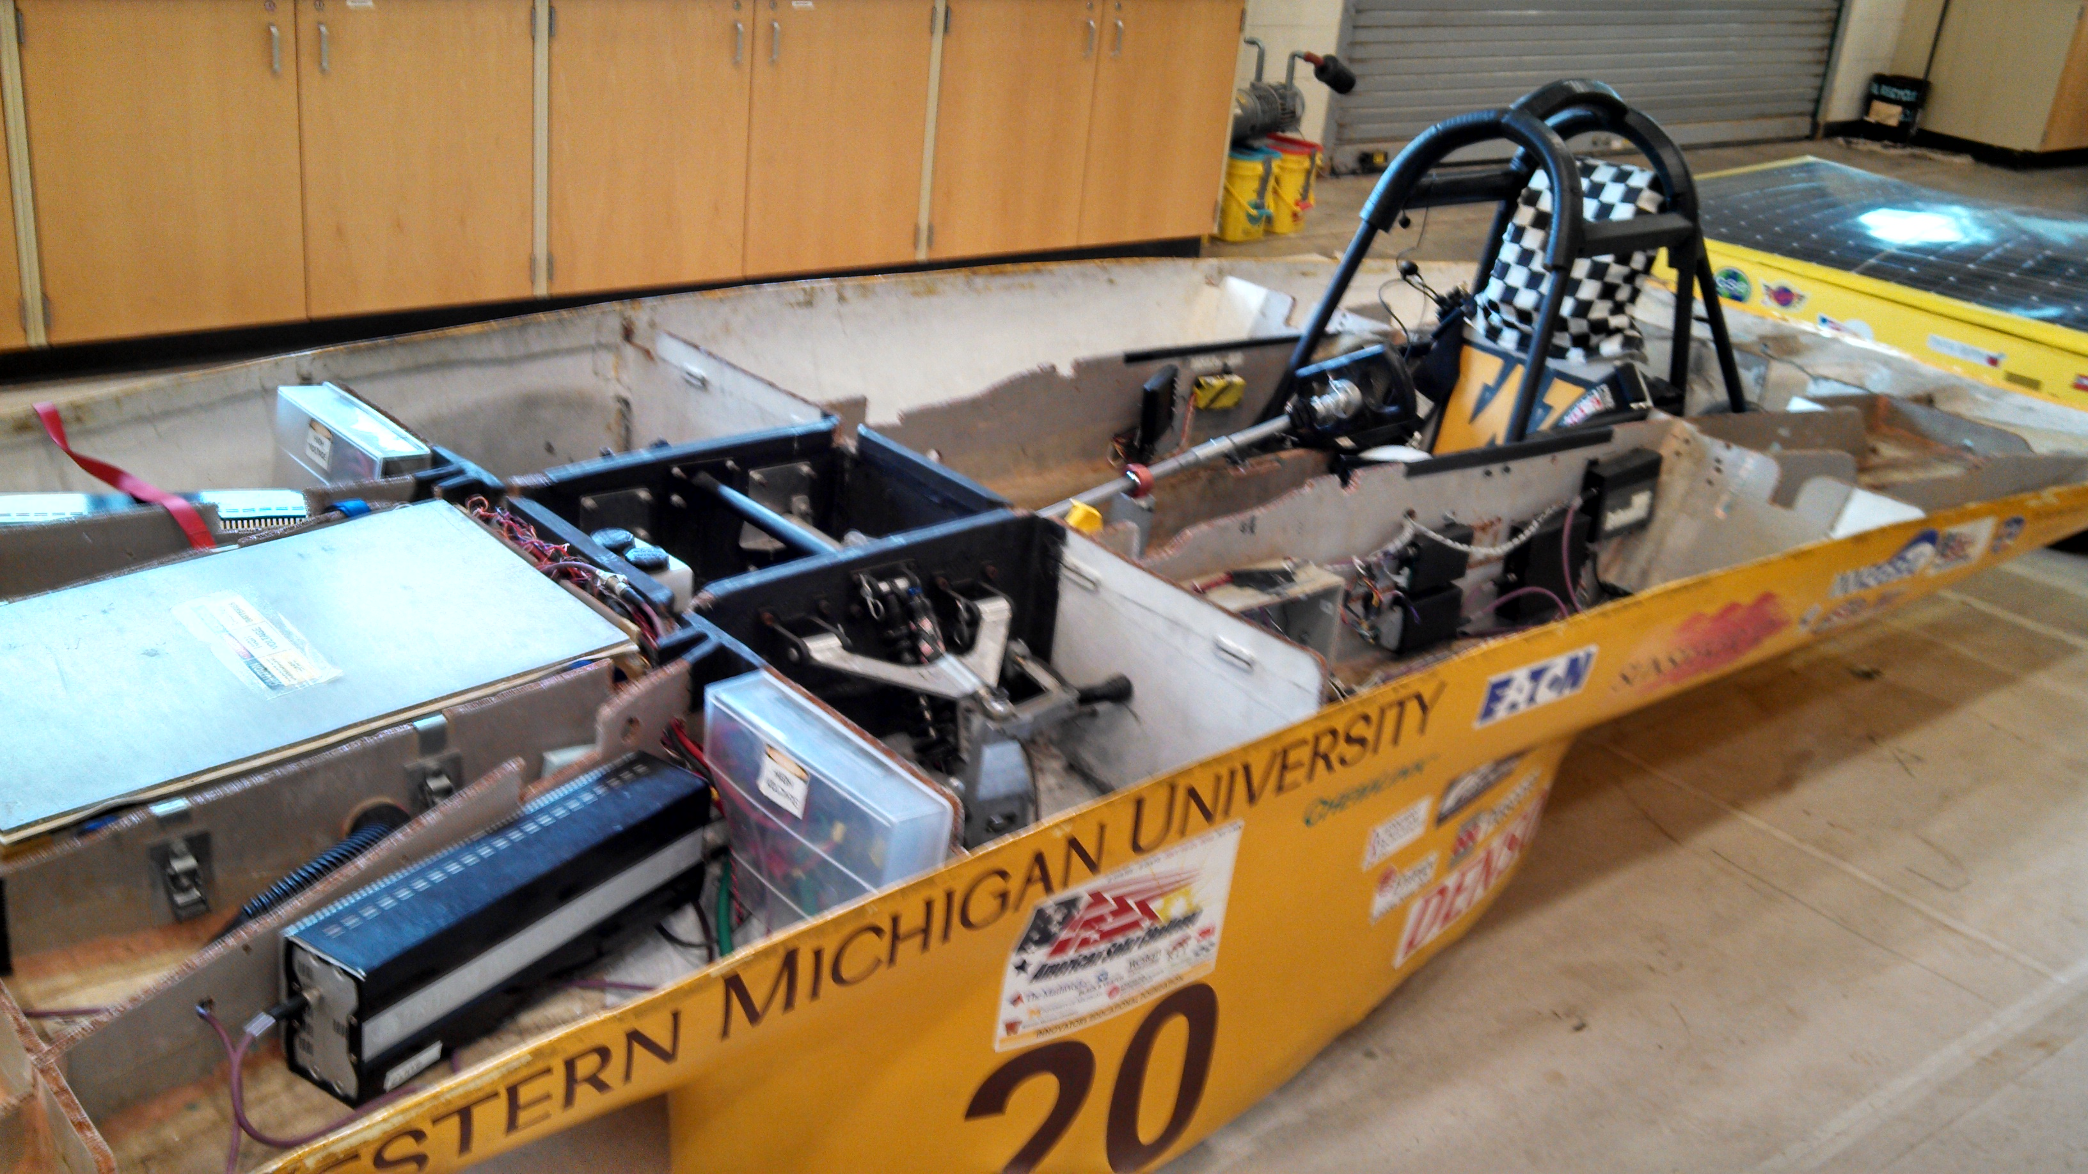
Fig 1-8

Fig 1-9
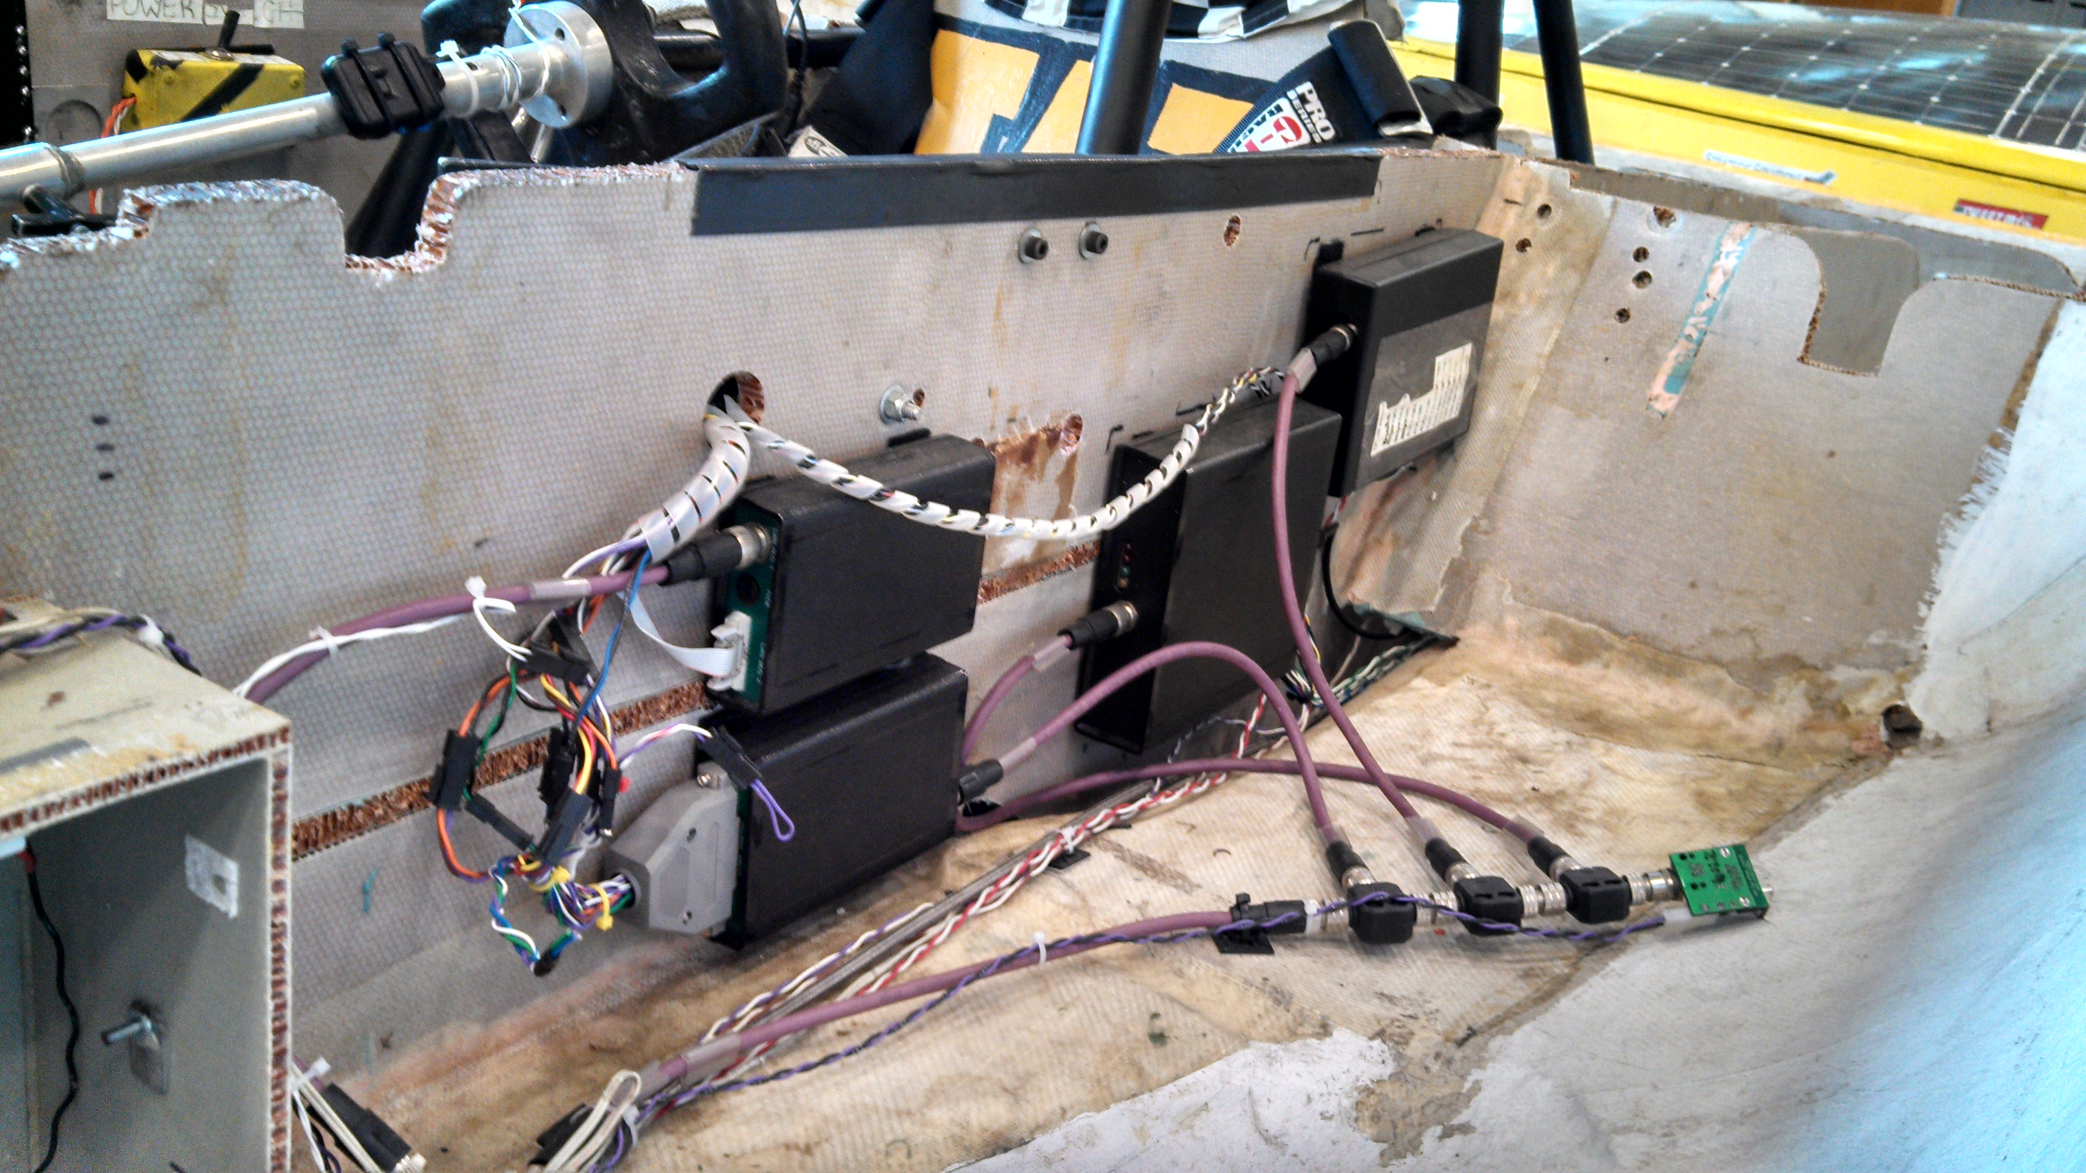

With so many devices sending unique messages over the same bus, there must be a way to handle data collisions. A data collision would occur when 2 devices sent a message at the same time, resulting in a combination of both packets and useless data. CAN handles these collisions in a unique way to insure that no collisions affect the transmitted data. When a devices CAN controller first gets a message to send, it checks the CAN bus to see if any messages are currently being transmitted. If a message is being sent over the bus, the controller waits until the message is complete and then when the bus is empty will send the frame Now if two devices try to send messages at the same moment the identifier bits will be used to determine which message has priority to continue.
Lets say that we have 2 devices that simultaneously try to send a CAN frame. As the bits of a packet are being sent along the bus they are also being monitored. If any dominate bit (0) is detected when a recessive bit (1) is trying to be sent the device sending the recessive bit stops transmitting and waits until the bus is free to try sending the message again. For example device 1 is sending a packet with an id of 0x402 and device 2 is sending a packet with an id of 0x502. Device 1's bits in the id section will be 10000000010 and devices 2's bits will be 10100000010. The first 2 bits, 10, of both packets will be sent along the bus since they are the same. When we come to the third bit of the identifiers device 2's CAN controller will notice that while trying to send a 1, another device was sending a zero. Since zero is the dominate bit in CAN, device 2 will stop sending it's packet and allow device 1 to continue.
Now that we have sent a CAN frame the CAN devices receiving the message must check to make sure there were no errors during the transmission.
The CAN protocol has five methods of error checking. They are, bit monitoring, bit stuffing, frame checking, acknowledgment check, and the cyclic redundancy check. Bit monitoring is performed by each device connected to the network monitoring the bus signals and verifying that the bit sent is actually the bit received. Bit stuffing happens when five consecutive bits at the same level are sent and a sixth bit is appended at the opposite level, allowing for an error to be detected if more than five bits at the same level are detected. Frame checking is possible through verifying the fixed format sections of a CAN frame, such as the CRC delimiter, ACK delimiter, and the EOF bit. An acknowledgment check is performed when each device correctly receiving the frame returns a dominant level in the ACK field of the frame, and an error is detected when a dominant bit in the ACK field is not detected by the transmitter. Finally, CRC checking is performed by each sent frame containing a 15-bit checksum while the receiver calculates its own and compares the two. Utilizing all five types of error checking make it almost impossible for a frame to be acknowledged by the receiver when an error has occurred.

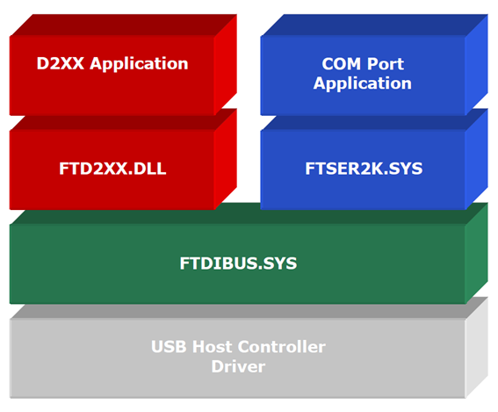Fig 2-1

Design
For our Alpha release, we used an object oriented style in C++. This includes multiple classes for communicating with the CANUSB hardware, sorting messages by ID, converting the messages to human readable form, and logging the messages to a csv file. All the output and execution of our Alpha core was strictly console based and sought only to test the back-end for Release 1.
The first class is CANusb, and handles all the communications with the actual CANUSB hardware. This class is multi-threaded with a read thread to handle all incoming messages. Read messages are stored in a FIFO queue for retrieval by other classes. The public methods for the CANusb class include: a constructor which handles the initial setup and connection to the hardware. A method for turning on and off the time stamp. Methods for retrieving CAN messages from the queue and checking the amount of messages in the queue. A method to set the baud rate of the CANUSB hardware. There are also methods to both open and close the CAN port for the retrieval of messages from the actual CAN bus. The CANusb class will isolate all interactions with the CAN hardware from the other classes in our project.
Our core also has a class for converting the messages from a CAN message to a human readable and decoded from. For each message id received from the CANusb class, there needs to be a conversion of the data section to either a float, string, or integer. This information is converted accordingly and the relevant data will be returned.
For logging the messages our client has expressed he wishes the log files to be in a csv from. Our logging class accepts both CAN messages and decoded data obtained from the conversion class. This data will then be output to a csv file which will contain the message id, time stamp, raw data, and translated data. Multiple csv files are used for each device connected to the CAN bus by the devices id, for example driver controller (400, 420), motor controller (500, 501). Therefore each csv file contains multiple types of messages from each device. This will allow our client to import the log files into excel where he can analyze them by device, or import all files and sort them by the time stamp to analyze all messages in the order they have been received.
To program the project we decided to use the Qt Framework. Qt is a streamlined IDE with many great tools and features some of which are depicted in Fig 2-2. One of the reasons we chose to use Qt is because it uses c++ as the coding language which we would be programming in as stated before. A feature of Qt that we found very beneficial was the great integrated version control system. We also made use of the ability to use qmake and Cmake for make files. One of the most beneficial abilities of Qt for our team is the use of Qthreads for cross platform threading, this feature allows us to easily produce our program across multiple operating systems. Qt also makes it very easy to integrate coding with the design of the graphical user interface. It will also be useful to continue to use for this project due to its compatibility with programing for mobile devices such as smart phones across many different operating systems, including Android and iOS.
Fig 2-2
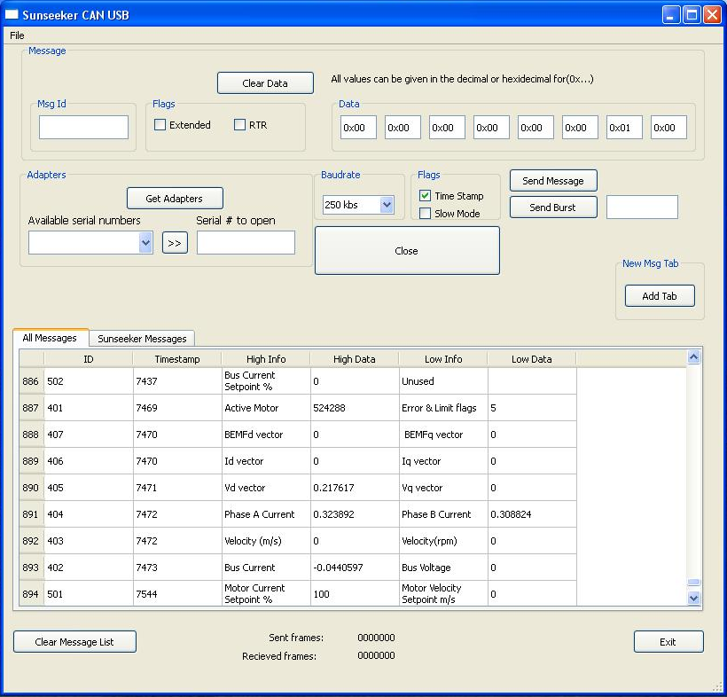
For release 1 we designed a new graphic user interface(UI) which makes use of our core. As you can see in Fig 2-3 we kept a similar layout as the old UI which should help ease the teams familiarity transition from the old UI. A key difference for our new UI is the message format in the message display box. As you can see in Fig 2-2 The ID, Timestamp, High Info High Data, Low Info, and Low Data fields are all separated in a table format, also the High Info and Low Info fields are custom massages for each message ID telling the user exactly what the information displayed means. Another key feature in the new UI is the ability to allow the user to add a tab to the message display box by clicking the “Add Tab” button. When the user clicks the “Add Tab” button a window, Fig 2-4, opens with a list of all of the active message IDs with check boxes next to them. The user can select either a single message ID or multiple message IDs from the that they want to watch and press the OK button. The program will then automatically add a new tab to the message display box which will only contain those message IDs Fig 2-5.
Fig 2-3
Fig 2-4
Fig 2-5

Design Implementation
Our Design implementation time line is presented in Gantt chart form, Fig 2-6 for clarity. The projects current progress can be seen as a yellow bar on the bottom with reference to the weeks to project has been under development.
Fig 2-6

Spikes
During the initial design phase there where some doubts raised about the CANUSB's ability to capture 100% of the can traffic while the CAN bus is under full load. Several different methods for evaluating the systems faculty under extreme conditions where considered. Amongst them was the possibility of using the spare CANUSB devices to flood the bus with numbered packets and comparing them to the messages received in order to detect if any message loss had occurred. This approach seemed promising at first but after doing more research into the capabilities of the CANUSB hardware, it became apparent that the transmission speed of the device is a fraction of its ability to receive. After careful deliberation the decision was made to utilize the Sunseeker telemetry board(Fig 3-1) to perform this operation of filling the CAN bus with a torrent of indexed activity. We arrived at this solution after discovering that the team's telemetry board is capable of transmitting at the CAN bus maximum of 1 Mbps. This method will require a C subroutine to be written for the MPS430 micro controller to generate the numbered messages and a subroutine for our software to verify message integrity.
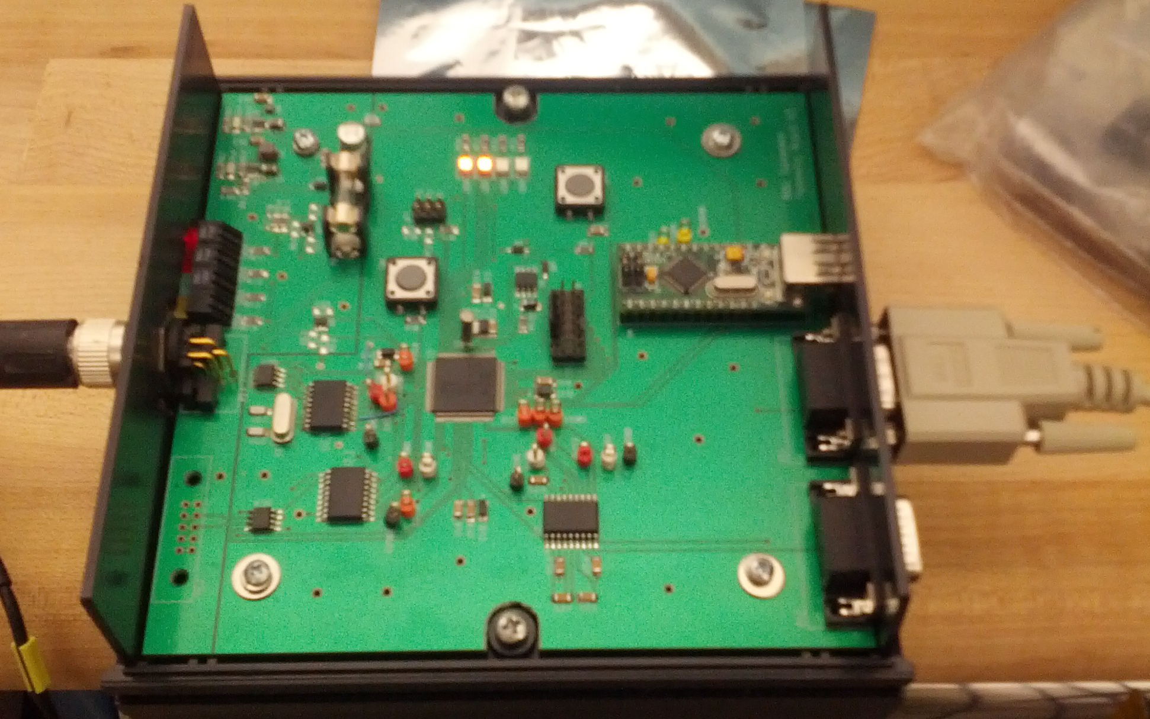Fig 3-1
After the decision was made to develop our own driver wrapper for the FTDI driver for release one it was suggested that a performance comparison between our solution and the the accepted LAWICEL wrapper. To do this we intend to adopt a similar approach to the one used to test the CANUSB under full load. We will develop a comparable wrapper routine for the LAWICEL wrapper and our solution to test and analyze differences in messages received and recognition time. These routines will will then be run simultaneously on independent systems while the telemetry board transmits numbered packets at full speed. After each message is received and processed it will be issued a system time stamp. These time stamps and any message discrepancies will then be compared and any differences in performance will be apparent.
After release one of our software utilizing the proprietary FTDI driver we intend to investigate the possible use of and libFTDI which is and open source library maintained by intra2net for talking to FTDI chips. This would be exceedingly useful for managing and understanding the buffers used in I/O operations and allow us much greater control over information flow. However, the FTDI driver currently in use does more than likely utilize more of the hardwares capabilities as it is developed by the manufacturer and probably contains chip specific operations which may not exist in the libFTDI driver. The performance drop compared to the enhanced ability to manipulate the code will have to be carefully weighed after performing similar tests to those mentioned previously. If the results of these tests indicate that the device is still able to capture 100% of the messages being transmitted then the libFTDI driver will most likely be adopted.

Stories

Release 1
- Check for possible hardware upgrades, i.e. USB High Speed
- Configure the CAN output into a csv file to be read more easily in an excel sheet
- Test the system by flooding the it to see if the system is receiving all the output, verify that we are receiving all of the output messages
- Format the coded output into something anyone can read and understand
- Design this as a cross-platform program from Linux, Windows 7, and Mac iOS with the driver from Future Technology Devices International
- Include the ability to add a tab to the message display box which only displays the messages that the user wants to see

Release 2
- Automated message returns for certain messages, i.e. an incoming battery over heat message could instantly trigger a shutdown message
- Color code the incoming codes so it can be easier to find what you are looking for
- Give the user the option to write all messages to a single csv file or write separate csv files for each different device

Release 3
- Add support for wireless interface
- Configure the output to be displayed on digital gauges inside the cockpit for the driver to read real time while driving, i.e. battery levels, rpm, ect.

Release 4
- Explore possible mobile device compatibility with our wireless output

Resources
- CANUSB adapter Fig 1-1

References
- “C Sample Program (Linux)”, from www.canusb.com/downloads
- Murphy, Nail. A short trip on the CAN bus. Embedded, 11 Aug. 2003. Web. 15 Nov. 2012. <http://www.embedded.com/electronics-blogs/murphy-s-law/4024614/A-short-trip-on-the-CAN-bus>
- What is CAN Bus?. CAN BUS. Web. 13 Nov. 2012. <http://canbuskit.com/what.php>
- CAN History. Can in Automation. Web. 20 Nov. 2012. <http://www.can-cia.de/index.php?id=161>
- Bagschik, Peter. An Introduction to CAN

Appendix

Fig 1-1
- CANUSB adapter

Fig 1-2
- Graphic of the devices inside of the CANUSB adapter

Fig 1-3
- GUI of the current program

Fig 1-4
- Comparison of the old multi-wire system and a CANBUS system

Fig 1-5
- What a CAN frame looks like

Fig 2-1
- FTDI Stack
Fig 2-2
- Graphic showing some of the Qt Framework's features
Fig 2-3
- Our newly designed User Interface
Fig 2-4
- The Add Tab window containing a list of active message IDs
Fig 2-5
- A close up shot of the message display box with a new tab added
Fig 2-6
- Project Gantt Chart

Fig 3-1
- Telemetry board

Glossary
- CAN – Controller Area Network
- CANUSB – adapter allowing a connection between the CANBUS and any USB device
- CVS – Comma Separated Value
- FIFO – First in first out
- FTDI – Future Techknology Devices International Ltd.
- GUI – Graphical User Interface
- LAWICEL – Company that designged and produces the CANUSB adapter
- LVDS – Low Voltage Diferential SIgnal
- qmake - a tool that helps simplify the build process for development project across different platforms
- QThreads - provides a platform-independent way to manage threads
- thread - the smallest sequence of instructions that can be managed independently by an operating system

Table of Contents
Background 1
Introduction 1
Client Introduction 1
CANUSB Background 1
Shortcomings of LAWICEL utility 4
What is CAN Bus 4
How CAN Bus Works 6
Design 9
Design Implementation 13
Spikes 14
Stories 16
Release 1 16
Release 2 16
Release 3 16
Release 4 16
Resources 16
References 17
Appendix 17
Fig 1-1 17
Fig 1-2 17
Fig 1-3 17
Fig 1-4 17
Fig 1-5 17
Fig 2-1 17
Fig 3-1 18
Glossary 19
Legal 21

Legal
This software is being developed and released under version 2 of the GNU General Public License published by the Free Software Foundation WITHOUT any warranty, neither expressed or implied. It is free software and you may modify and distribute it in accordance with GPL 2.0. A copy of this license will be included in any release of this software and is also freely available @ http://www.gnu.org

